Step 1:

     Check for lock on any table.

     Query:

*column oracle_username format a20*

*column os_user_name format a15*

*column object_name format a30*

*column object_type format a37*

*column owner format a20*

*column "OBJECT OWNER" for a30*

*set lines 188 pages 2000*

*select a.session_id,a.oracle_username, a.os_user_name, b.owner "OBJECT OWNER", b.object_name,b.object_type,a.locked_mode*

*from (select object_id, SESSION_ID, ORACLE_USERNAME, OS_USER_NAME, LOCKED_MODE from v$locked_object) a,*

*(select object_id, owner, object_name,object_type from dba_objects) b*

*where a.object_id=b.object_id;*

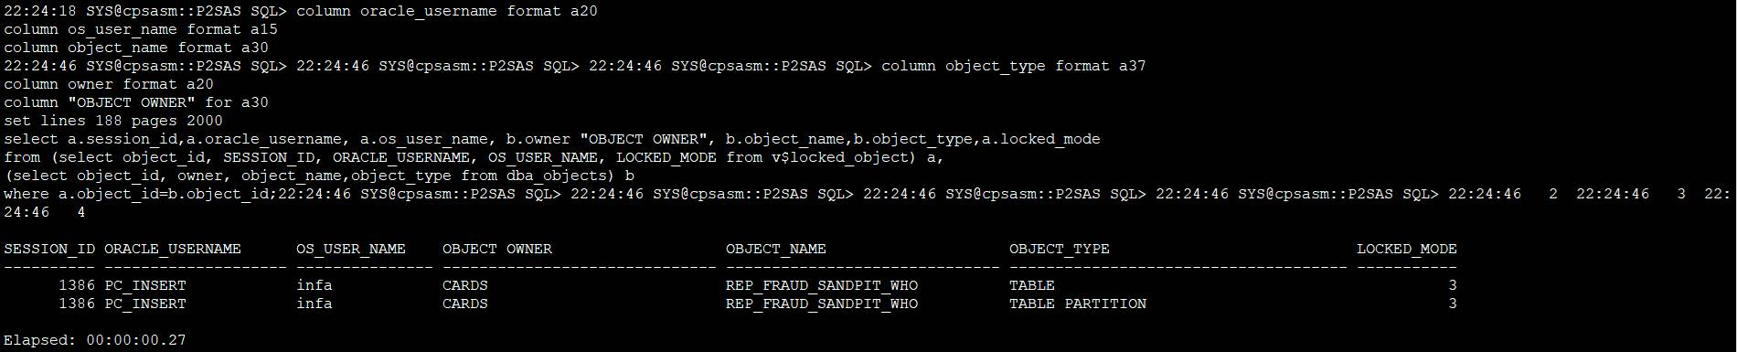

As you can see SID **1386** is the locking session which need to be killed.

Step 2:

Kill session_id **1386**.

Query:

*select /*+RULE*/ 'alter system kill session '''||sid||','||serial# ||''' immediate;' from v$session where sid in (&SID);*

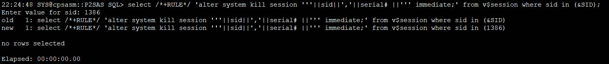

As you can see – **no rows selected**. The reason is **SERIAL#** is **ZERO**.

Step 3:

Get **SID and SERIAL#** information for **SID:1386**.

Query:

*set lines 188 pages 2000*

*col MACHINE for a30*

*col OSUSER for a20*

*select sid,serial#,status,machine,osuser,to_char(LOGON_TIME, 'DD-MON-YYYY hh24:mi:ss') as LOGON_TIME*

*from v$session where sid='&sid'*

*order by logon_time;*

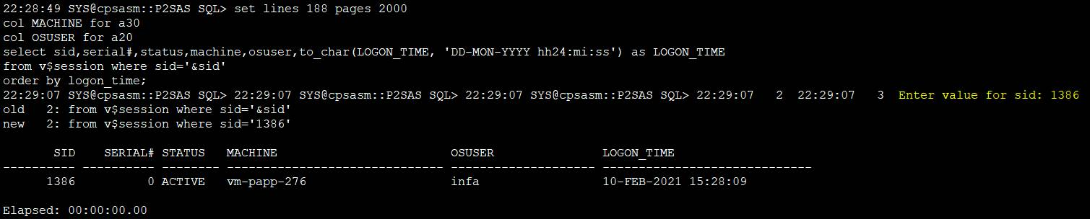

As you see from above screen-shot **SERIAL#** for **SID:1386 is ZERO**.

Step 4:

Get **SPID** for **SID:1386**.

Query:

*set lines 200*

*col sid format 99999*

*col username format a15*

*col osuser format a15*

*select a.sid, a.serial#,a.username, a.osuser, b.spid*

*from v$session a, v$process b*

*where a.paddr= b.addr*

*and a.sid='&sid'*

*order by a.sid;*

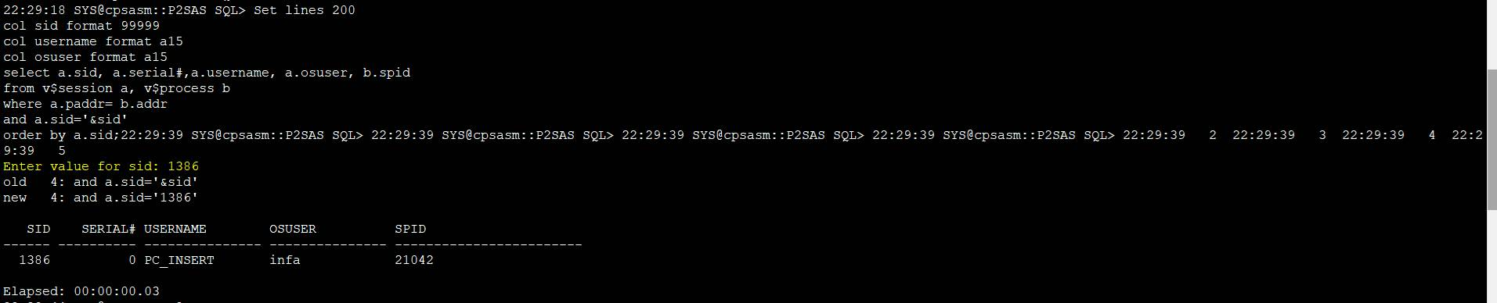

Step 5:

**Check and Kill SPID session**.

Query:

*Kill -9 <SPID>* ====> OS level command to kill SPID.

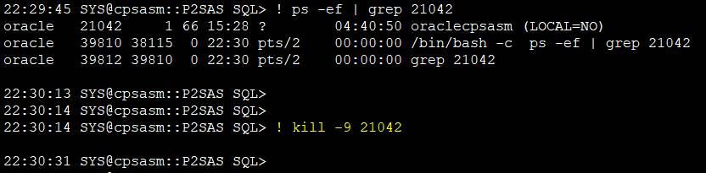

Once SPID is killed. Check again is there any lock. Use query from Step 1.

